[ Insert official UPAEP logo ]
UPAEP · Decanato de Ingenierías
EVIDENCE — US25-T2
Design the registration screens
SmartGreenAI: Cilantro Crop

1. Task information
Task ID | US25-T2
User Story | US-25 — Register IoT devices, sensors and actuators
Sprint | Sprint 2 (2026-09-21 – 2026-10-09)
Week | Week 2
Responsible | Alexis Enrique Valle Parra
Peer reviewer | Jorge Velez Delgado
Planned / actual hours | 1 h / 1 h
Completed on | October 2, 2026
Status | Done

2. Task description
Prototype the screens: device list, form to register a device and add its sensors and actuators.

3. Completion conditions
✓ Condition 1: Prototype includes device list and registration form.
How it was verified: The screens include the device list and the device registration form.
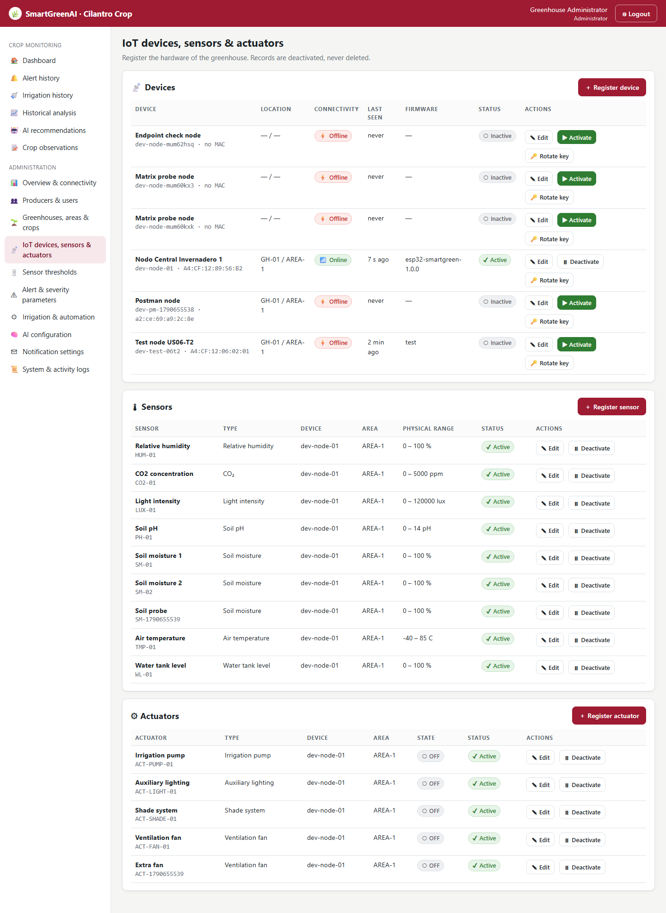
Figure US25-T2-1. Device list with connectivity, firmware and status, followed by the sensors and actuators of each device. (US25-T2_Design_Registration_Screens_1.png)
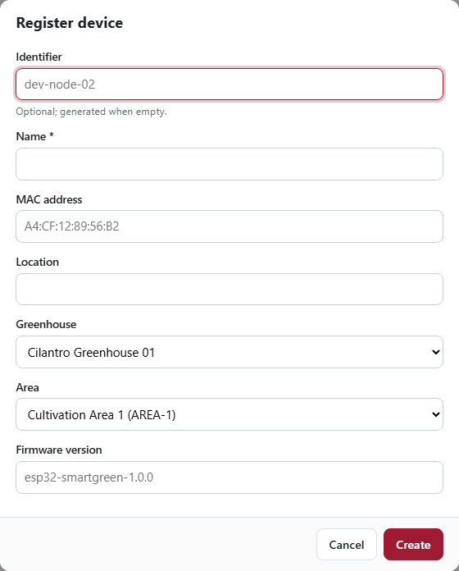
Figure US25-T2-2. Registration form of a device (name, MAC, location, greenhouse, area, firmware). (US25-T2_Design_Registration_Screens_2.png)
✓ Condition 2: Form allows adding sensors and actuators to a device.
How it was verified: The sensor and actuator forms add components to a device through the Device selector.
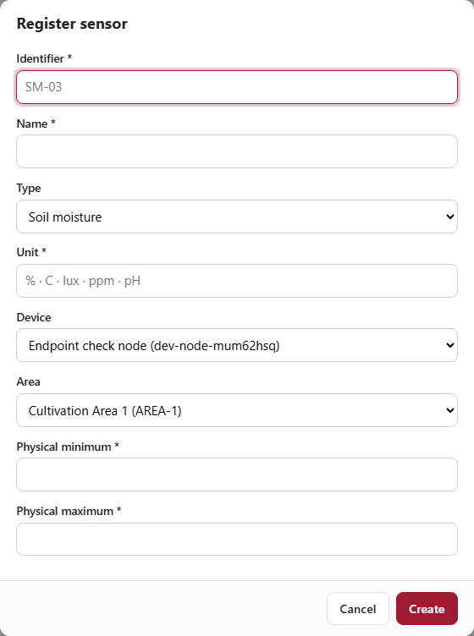
Figure US25-T2-3. Adding a sensor to a device: the Device selector links the new sensor to its device. (US25-T2_Design_Registration_Screens_3.png)
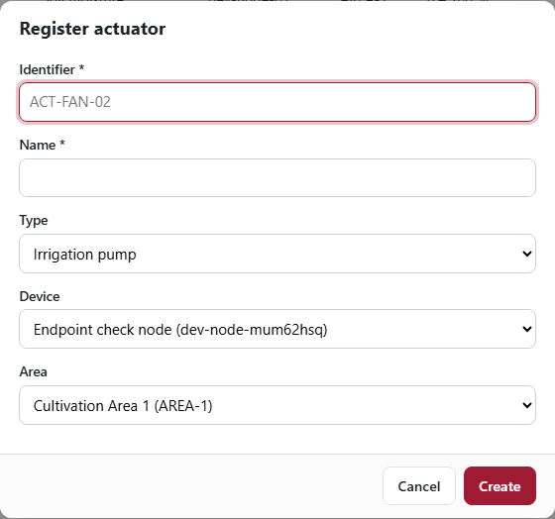
Figure US25-T2-4. Adding an actuator to a device. (US25-T2_Design_Registration_Screens_4.png)
✓ Condition 3: Prototype reviewed by the team.
How it was verified: The screens were reviewed by the team in the Week 2 milestone review (approval record).
✓ Condition 4: Evidence: Screen prototype reviewed by the team.
How it was verified: Screen prototype reviewed by the team (Figures 1–4 show the implemented screens).

4. Attached files
- US25-T2_Design_Registration_Screens_1.png
- US25-T2_Design_Registration_Screens_2.png
- US25-T2_Design_Registration_Screens_3.png
- US25-T2_Design_Registration_Screens_4.png

5. Traceability
Related requirements | FR-05, FR-06, FR-07, NFR-02, NFR-09
Implementation | See docs/TRACEABILITY.md
Verification | See docs/TRACEABILITY.md

6. Sign-off
Role | Name | Date | Signature
Responsible | Alexis Enrique Valle Parra | October 2, 2026
Peer reviewer | Jorge Velez Delgado | October 2, 2026
Product Owner acceptance | Alexis Enrique Valle Parra | October 2, 2026
Approval record: Daily Meeting 3 of Sprint 2 (Monday, October 5, 2026), team update — "Review of the Week 2 milestone: all endpoints, storage, transmission, threshold, registry and actuator features implemented and connected."

